KAPTURE FINANCE – COLLECTIONS VOICEBOT (MAYA)
High-Level Design (HLD) | AI Delivery Intern Take-Home Assignment

1. Overview & Objectives
Maya is an outbound AI voice collections agent for Kapture Finance. It authenticates the intended customer before disclosing debt information, explains the overdue EMI, understands intent, and drives an appropriate next step such as promise-to-pay (PTP), payment-link delivery, callback, or escalation. The design prioritizes authentication, fair-collection behavior, data minimization, deterministic state control, and observability.
- Authenticate before any debt/overdue information is disclosed.
- Use clear self/company/purpose disclosure and respectful tone.
- Capture payment intent, PTP date/amount, payment mode, and disputes.
- Support mocked payment-link delivery.
- Handle already-paid, hardship, dispute, wrong-person, DNC, hostile, voicemail/no-input, and callback scenarios.
- Log a disposition for every completed or terminated call.

2. Architecture & Pipeline
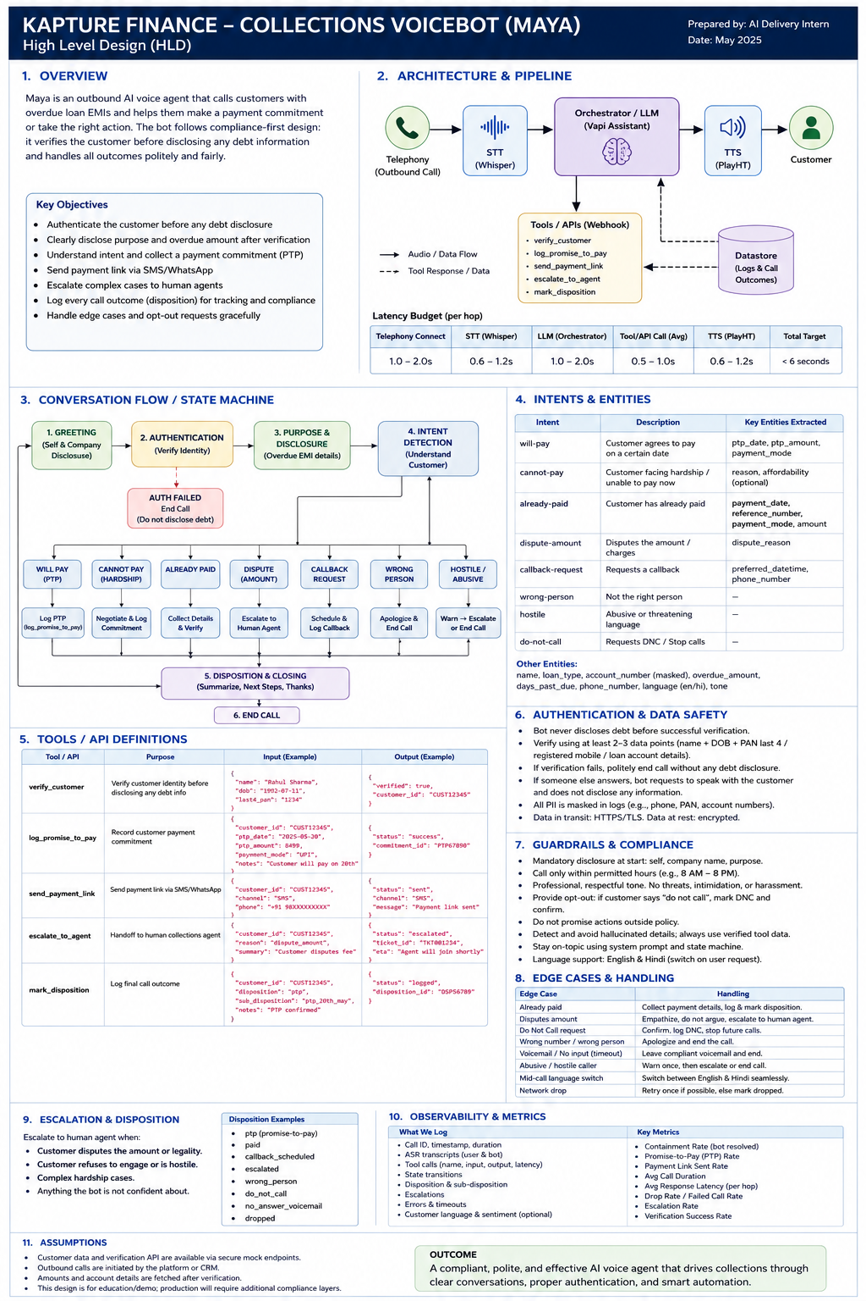
Figure 1. Reference architecture and conversation state design.
Pipeline: Telephony → STT → Vapi assistant/orchestrator + LLM → TTS → customer. The assistant invokes scoped HTTPS webhook tools. A datastore/CRM records verification results, call events, dispositions, and operational metrics. The current Vapi build implements verify_customer, log_promise_to_pay, and send_payment_link; production design additionally recommends escalate_to_agent and mark_disposition.
Hop | Target latency | Design note
Telephony connect | 1–2 s | Connection/setup target
STT | 0.6–1.2 s | Streaming transcription
LLM/orchestrator | 1–2 s | Short prompts + state/tool gates
Tool/API | 0.5–1 s avg | Timeouts and safe retries
TTS | 0.6–1.2 s | Streaming preferred
End-to-end turn | < 6 s | Natural turn-taking target

3. Conversation Flow / State Machine
Authentication is state-enforced: the assistant must not transition into debt disclosure or collections negotiation until verification succeeds. The orchestrator/tool layer should maintain an authenticated=true state flag and gate debt-related fields on it; prompt instructions alone are not sufficient.
State | Purpose | Transition lock
GREETING | Self/company disclosure | Always first; no debt information
AUTHENTICATE | Verify identity | Must succeed before disclosure
DISCLOSE_PURPOSE | Explain purpose + overdue amount | authenticated=true only
DETECT_INTENT | Understand customer response | authenticated=true
RESOLVE | PTP, hardship, paid, dispute, callback, payment link, escalation | Intent/tool gates
DISPOSITION | Record outcome | Required before normal completion
END | Safe closing/termination | After disposition or terminal case

4. Intents & Entities
Intent | Handling | Entities
will-pay | Confirm and record PTP | ptp_date, ptp_amount, payment_mode
cannot-pay / hardship | Acknowledge; negotiate within policy or escalate | reason, preferred_date, affordable_amount
already-paid | Collect details and verify/route; no duplicate demand | payment_date, payment_mode, reference_number
dispute | Capture reason; do not argue; escalate/review | dispute_reason, disputed_amount
callback-request | Schedule callback | preferred_datetime, phone_number
wrong-person | No debt disclosure; end safely | none
hostile / abusive | Calm boundary; escalate/end | none
do-not-call | Stop and record DNC | none
voicemail / no-input | Approved generic message if allowed, otherwise end | none
language-switch | Switch EN/HI with same safety gates | language

5. Tools / API Definitions
Implemented in the Vapi build:
Tool | Inputs | Outputs | Purpose
verify_customer | name; approved verification factor | verified; customer_id | Verify identity
log_promise_to_pay | customer_id; ptp_date; ptp_amount; payment_mode; notes | status; commitment_id | Record PTP
send_payment_link | customer_id; amount; channel; contact | status; channel; payment_link | Send/mock payment link

Recommended production extensions:
Tool | Inputs | Outputs | Purpose
get_account_details | customer_id | overdue_amount; days_past_due; product | Trusted account facts
escalate_to_agent | customer_id; reason; summary | status; ticket_id | Human handoff
mark_disposition | customer_id; disposition; notes | status; disposition_id | Final outcome logging

6. Authentication & Data Safety
- No overdue amount, loan type, account status, or debt details before successful verification.
- Use at least two approved verification factors; never request OTPs, PINs, passwords, CVV, or unnecessary secrets.
- If a third party answers, do not disclose debt; ask for the intended customer without revealing the reason.
- Failed verification terminates or follows an approved retry policy; no bypass.
- Minimize PII in logs and mask identifiers/payment references.
- Use HTTPS/TLS in transit and encryption/access controls at rest.
- Trusted tool responses are authoritative; the LLM must not fabricate amounts, dates, statuses, or links.

7. Guardrails & Compliance
- Mandatory self/company/purpose disclosure and permitted calling hours.
- No threats, intimidation, harassment, deceptive claims, or prohibited pressure.
- Immediate do-not-call/opt-out handling and disposition.
- Never claim payment success without trusted payment-status confirmation.
- Stay on-topic and redirect unrelated requests.
- Use deterministic state/tool gates for sensitive actions.
- Support English/Hindi switching while preserving the same safety rules.

8. Edge Cases & Handling
Edge case | Expected handling
Already paid | Collect payment details; verify/route; no duplicate demand
Dispute amount | Capture reason; no argument; escalate/review
Do not call | Confirm, mark DNC, stop
Wrong person / wrong number | No disclosure; apologize and terminate
Voicemail / no input | Approved generic message if allowed, otherwise end
Hostile caller | Calm boundary; escalate/end
Language switch | EN/HI with unchanged safety gates
Network/API failure | Safe retry; otherwise explain/escalate/log
Tool invalid/missing data | Do not guess; clarify or escalate
Human request | Escalate immediately

9. Escalation & Disposition
Escalate when the customer disputes the debt/amount, reports hardship beyond allowed automation policy, requests a human, becomes hostile, or when the agent/tool cannot confidently resolve the case. Every call should end with a disposition such as PTP, paid, dispute, callback_scheduled, escalated, wrong_person, do_not_call, no_answer_voicemail, or dropped.

10. Observability & Metrics
What to log | Metrics
Call ID, timestamps, duration | Containment/resolution rate
ASR/turn timing | PTP rate
Tool name/status/latency | Payment-link sent rate
State transitions | Average response latency
Disposition/escalation reason | Drop/failed-call rate
Errors/timeouts/retries | Verification success rate
Language/sentiment where permitted | Escalation/dispute rate

11. Testing Strategy
- Happy path: verified → overdue disclosure → will-pay → PTP recorded.
- Payment-link: verified → requests link → SMS selected → tool succeeds.
- Already-paid: payment details collected; no duplicate payment demand.
- Wrong-person and DNC: no disclosure and safe termination.
- Dispute: capture reason and escalate.
- Tool failure: no hallucinated result.
- Authentication bypass attempt: debt details remain blocked.
- Silence/no-input, hostile caller, callback, and language-switch tests.
- Regression-test each published prompt/tool version against the state machine.

12. Implementation Notes & Assumptions
- Current Vapi build uses mocked HTTPS endpoints exposed through ngrok for development/testing.
- Implemented tools: verify_customer, log_promise_to_pay, send_payment_link.
- Production would add authenticated server endpoints, persistent CRM/account data, payment-status verification, human handoff, and disposition APIs.
- Trusted backend services provide account facts; the LLM does not invent financial data.
- Reference scenario: Rahul Sharma, personal loan, overdue EMI ₹8,499, 12 days past due.
- Latency figures are engineering targets, not measured production SLAs.

13. Current Vapi Build Mapping
Capability | Status
Maya assistant + voice | Implemented and tested
First message | Implemented and tested
verify_customer | Published and tested
log_promise_to_pay | Published and tested
send_payment_link | Published and tested
Promise-to-pay scenario | Tested
Already-paid scenario | Tested
Human escalation conversation | Tested
Production escalate_to_agent API | Not implemented
Production mark_disposition API | Not implemented
Real payment-status confirmation | Not implemented; mock flow

Conclusion
The design provides a compliant, state-controlled collections voicebot that automates routine conversations while protecting customer data and providing safe paths for PTP, payment links, already-paid claims, disputes, opt-outs, callbacks, and human escalation. The key engineering control is explicit authentication state-gating before debt disclosure.

